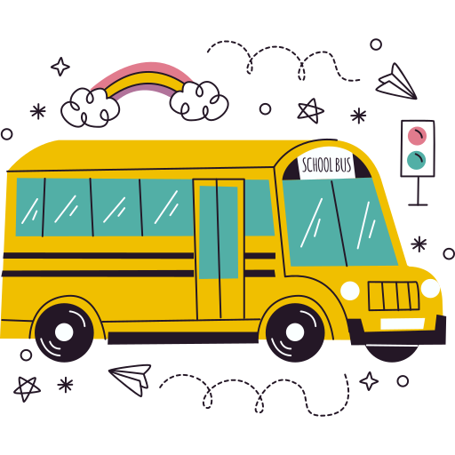

AFTER SCHOOL SCHEDULE


Schedule |  | Mon | Tue | Wed | Thu | Fri | Sat
Get rid of Belongings
Unpack back pack
Put away your clothes, shoes
Freshen up
Eat A Snack
Have a Healthy Snack
Complete Home Work for the Day
Complete any assignment, project or prepare for any
upcoming test
Cleaning Time
Clean your room, dishes, and keep clean your bag
Refreshment
Have a light snack or juice
Fun Time
Time to watch TV, Play any games, readings, stories
Get Ready for Tomorrow
Pack your bag, Make your clothes, shoes ready f
or next day
Dinner and Bed Time
Have your dinner, pray for the day and go to bed to get
up on time for next day
https://www.scheduletemplate.org/

