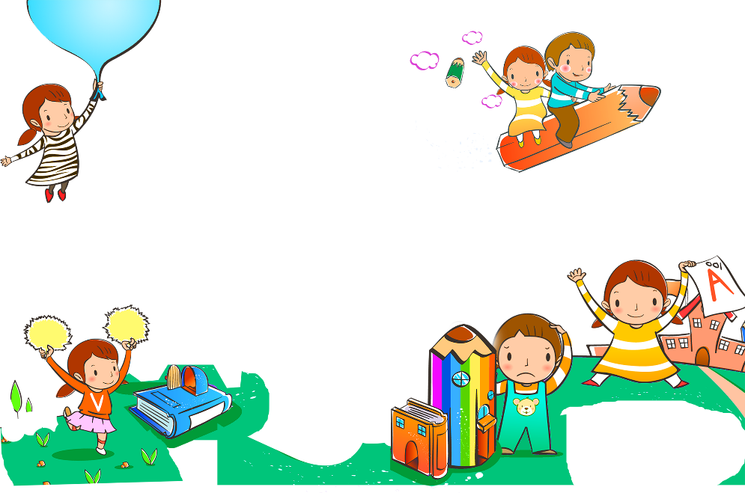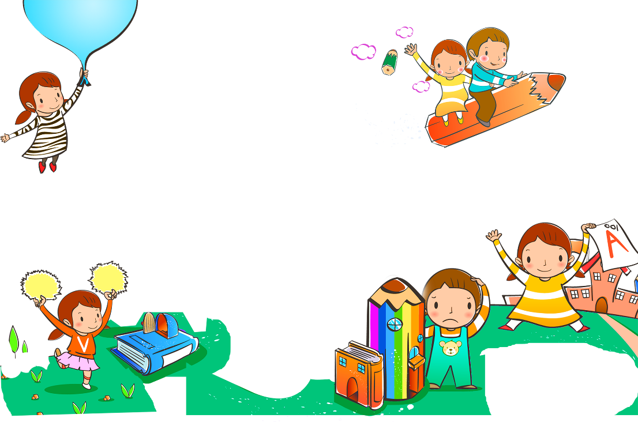

**After School Schedule**

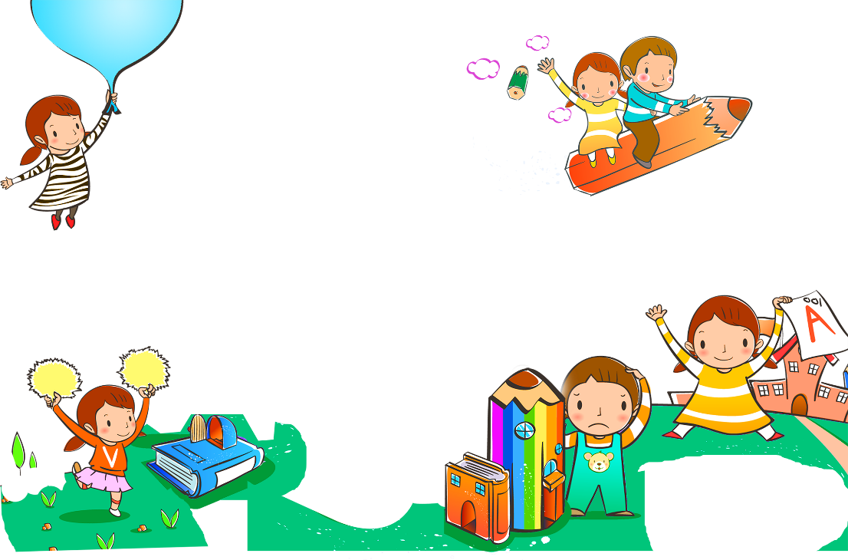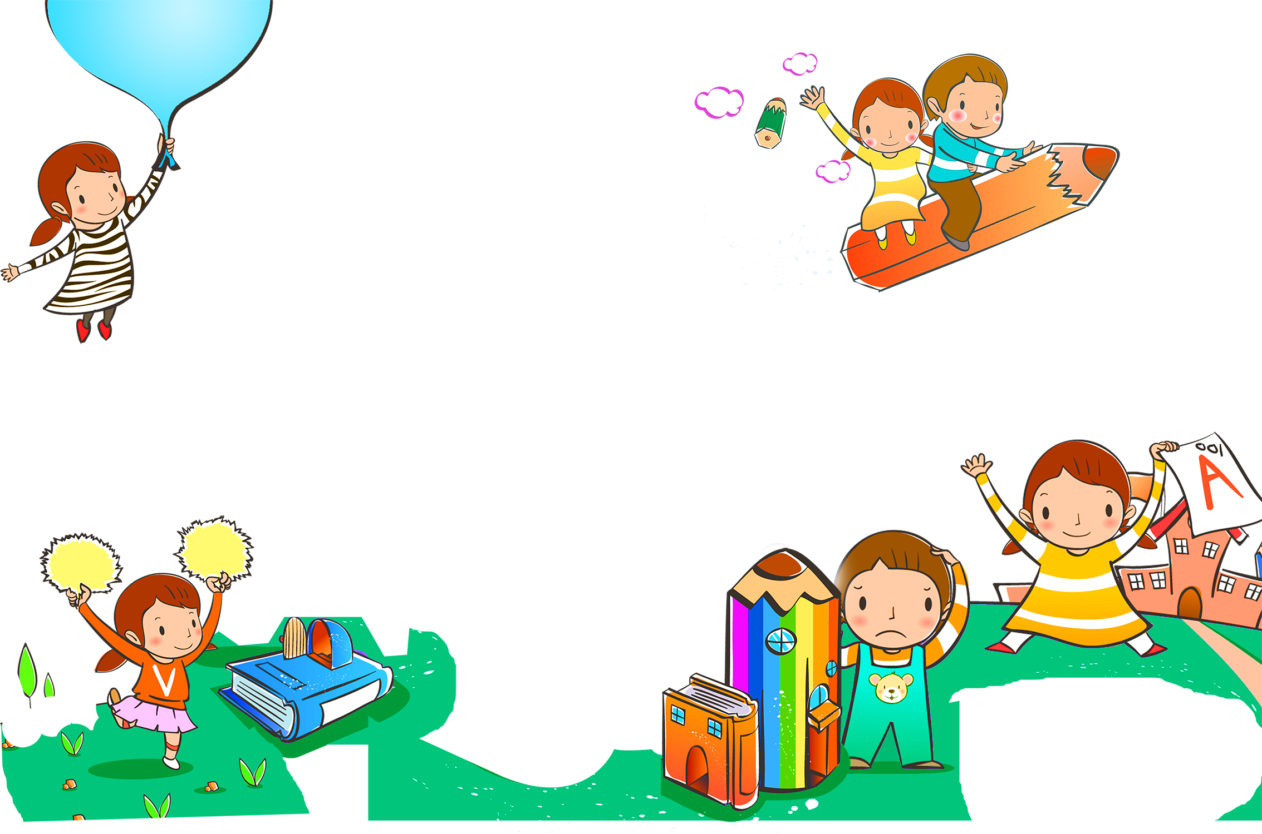

|  |  |  |  |
| --- | --- | --- | --- |
| **Time** | **After School Activity** |  | **Notes** |
| **Hang Up Coat** | | |  |
|  | Empty Backpack |  |
|  | Look at my assignments for the day |  |
|  | Make sure I have everything I need for homework |  |
|  | Give Mom or Dad any parent papers |  |
|  | Clean out lunch box |  |
| **Have a Snack** | | |
|  | Wash my hands first |  |
|  | Tell Mom and Dad about my day |  |
| **Relax and unwind. I can…** | | |
|  | Read a book |  |
|  | Go outside and play |  |
|  | Play a game |  |
|  | Invite a friend over (ask Mom or Dad first) |  |
| **Do My Homework** | | |
|  | Double check my work |  |
|  | Pack my backpack for tomorrow |  |
|  | Dinner and Chores | |
|  | Help set/clear the table |  |
|  | Take out the trash |  |
|  | Other: |  |
| **TV or Computer Time** | | |
|  | Stick to the time limit |  |

***https://www.scheduletemplate.org/***